**Experiment 9– Load Balancing Algorithm**

**Learning Objective:** Student should be able to develop a program for Load Balancing Algorithm.

**Tools :**Java

**Theory:**

**Load Balancing Algorithm:**

The scheduling algorithms using this approach are known as load-balancing algorithms or load-leveling algorithms. These algorithms arc based on the intuition that, for better resource utilization, it is desirable for the load in a distributed system to be balanced evenly. Thus, a load-balancing algorithm tries to balance the total system load by transparently transferring the workload from heavily loaded nodes to lightly loaded nodes in an attempt to ensure good overall performance relative to some specific metric of system performance. When considering performance from the user point of view, the metric involved is often the response time of the processes. However, when performance is considered from the resource point of view, the metric involved is the total system throughput. In contrast to response time, throughput is concerned with seeing that all users are treated fairly and that all are making progress. Notice that the resource view of maximizing resource utilization is compatible with the desire to maximize system throughput. Thus the basic goal of almost all the load-balancing algorithms is to maximize the total system throughput.

**Static versus Dynamic**

At the highest level, we may distinguish between static and dynamic load-balancing algorithms. Static algorithms use only information about the average behavior of the system, ignoring the current state of the system. On the other hand, dynamic algorithms react to the system state that changes dynamically.

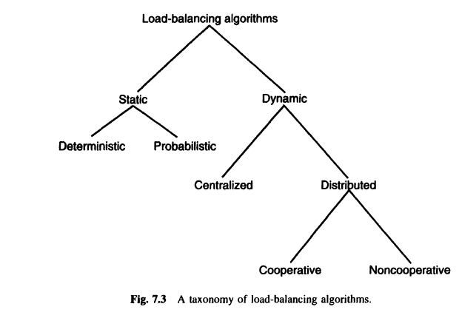

**Deterministic versus Probabilistic**

Static load-balancing algorithms may be either deterministic or probabilistic. Deterministic

algorithms use the information about the properties of the nodes and the characteristics of the

processes to be scheduled to deterministically allocate processes to nodes. Notice that the task

assignment algorithms basically belong to the category of deterministic static load-balancing

algorithms.

**Centralized versus Distributed**

Dynamic scheduling algorithms may be centralized or distributed. In a centralized dynamic

scheduling algorithm, the responsibility of scheduling physically resides on a single node. On

the other hand, in a distributed dynamic scheduling algorithm, the work involved in making

process assignment decisions is physically distributed among the various nodes of the system.

In the centralized approach, the system state information is collected at a single node at which

all scheduling decisions are made. This node is called the centralized server node. All

requests for process scheduling are handled by the centralized server, which decides about the

placement of a new process using the state information stored in it. The centralized approach

can efficiently make process assignment decisions because the centralized server knows both

the load at each node and the number of processes needing service. In the basic method, the

other nodes periodically send status update messages to the central server node. These

messages are used to keep the system state information up to date at the centralized server

node. One might consider having the centralized server query the other nodes for state

information. This would reduce message traffic if state information was used to answer

several process assignment requests, but since nodes can change their load any time due to

local activities, this would introduce problems of stale state information.

**Cooperative versus Noncooperative**

Distributed dynamic scheduling algorithms may be categorized as cooperative and

noncooperative. In noncooperative algorithms, individual entities act as autonomous entities

and make scheduling decisions independently of the actions of other entities. On the other

hand, in cooperative algorithms, the distributed entities cooperate with each other to make

scheduling decisions. Hence, cooperative algorithms are more complex and involve larger

overhead than noncooperative ones. However, the stability of a cooperative algorithm is

better than that of a noncooperative algorithm.

**Exercise:**

1. **Explain issues in load balancing algorithm?**

**Result and Discussion:** .…………………………………………………………………………………………………

…………………………………………………………………………………………………..

**Learning Outcomes:** The student should have the ability to

LO1: Comprehend the Load balancing concept

LO2: Analyze different that load balancing methods

**Course Outcomes:** Upon completion of the course students will be able to understand Load Balancing Algorithm.

**Conclusion:**……………………………………………………………………………………

…………………………………………………………………………………………………

………………………………………………………………………………………………...

**Viva Questions:**

1. State difference between static and Dynamic?
2. Compare Deterministic versus Probabilistic?
3. Contrast between Cooperative versus Noncooperative?
4. Explain load balancing Algorithm?



**For Faculty Use**

|  |  |  |  |  |
| --- | --- | --- | --- | --- |
| **Correction Parameters** | **Formative Assessment [40%]** | **Timely completion of Practical [ 40%]** | **Attendance / Learning Attitude [20%]** |  |
| **Marks Obtained** |  |  |  |